User manual with pictures of the application

This is the main application window on start-up.

Option 1:

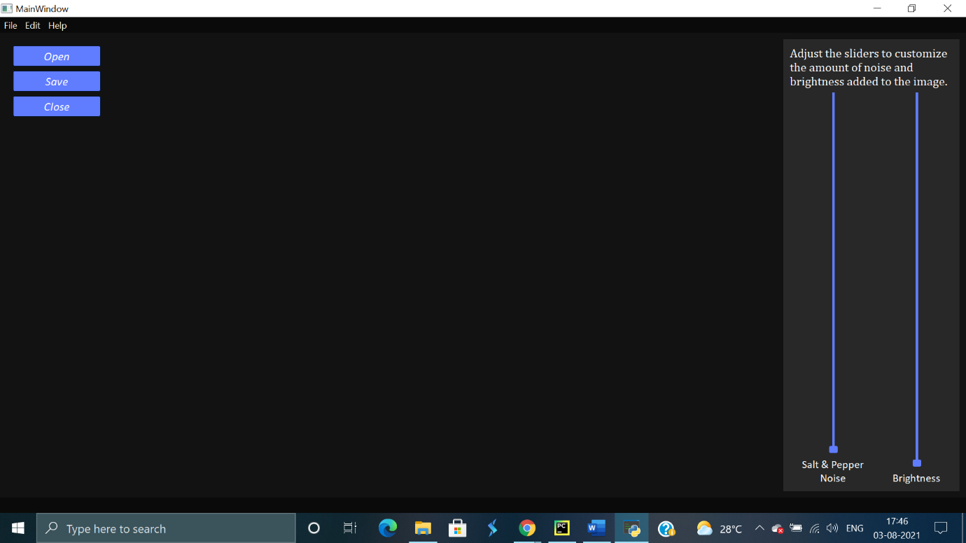

Option 2:

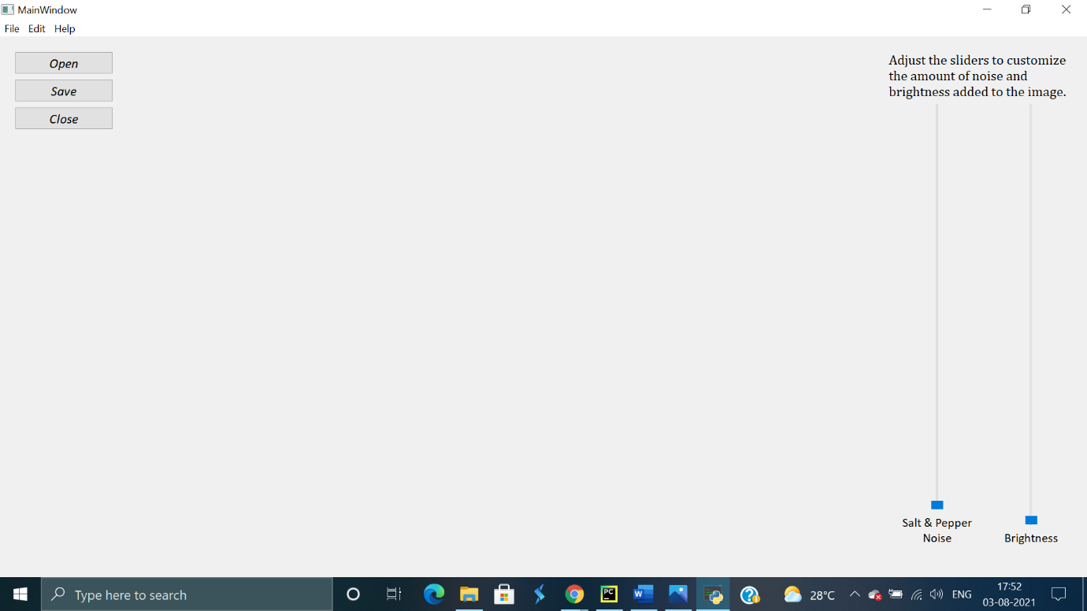

When you click open, you can select any image from any directory you choose. The image formats supported are:

* jpg
* png
* tiff
* bmp

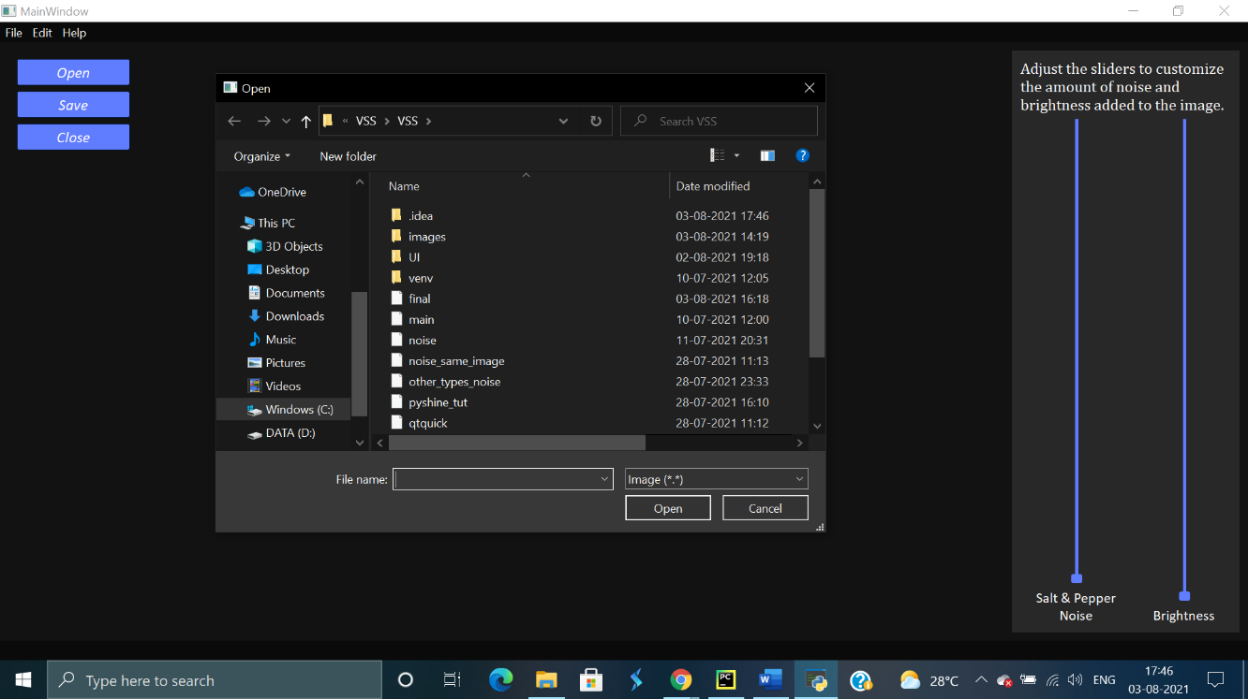

The image would load as seen. Any image you choose will get resized according to the window size.

*Sample vertical image:*

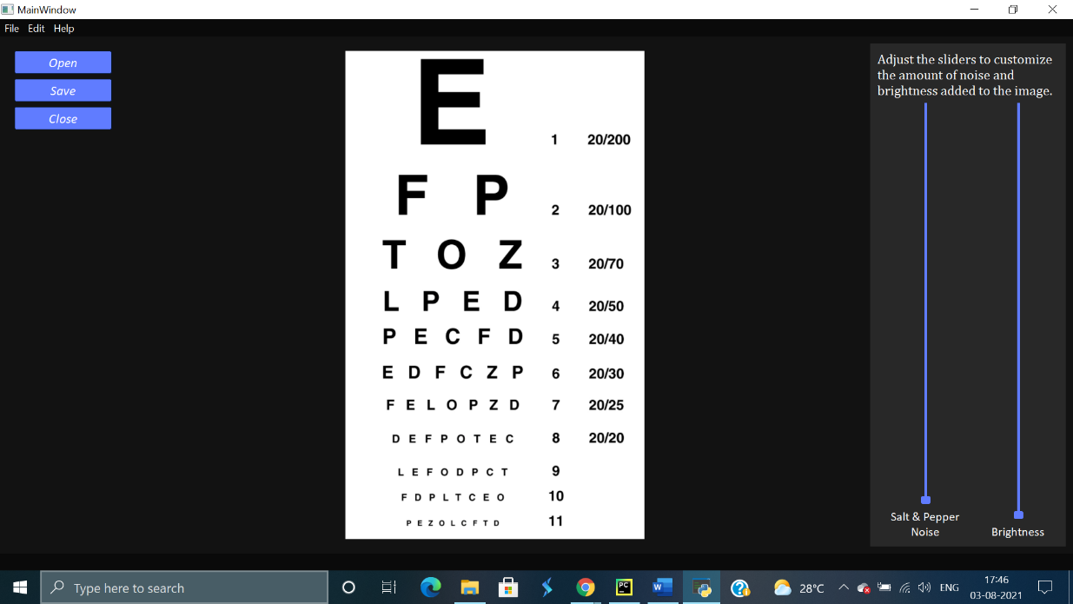

*Sample Horizontal image:*

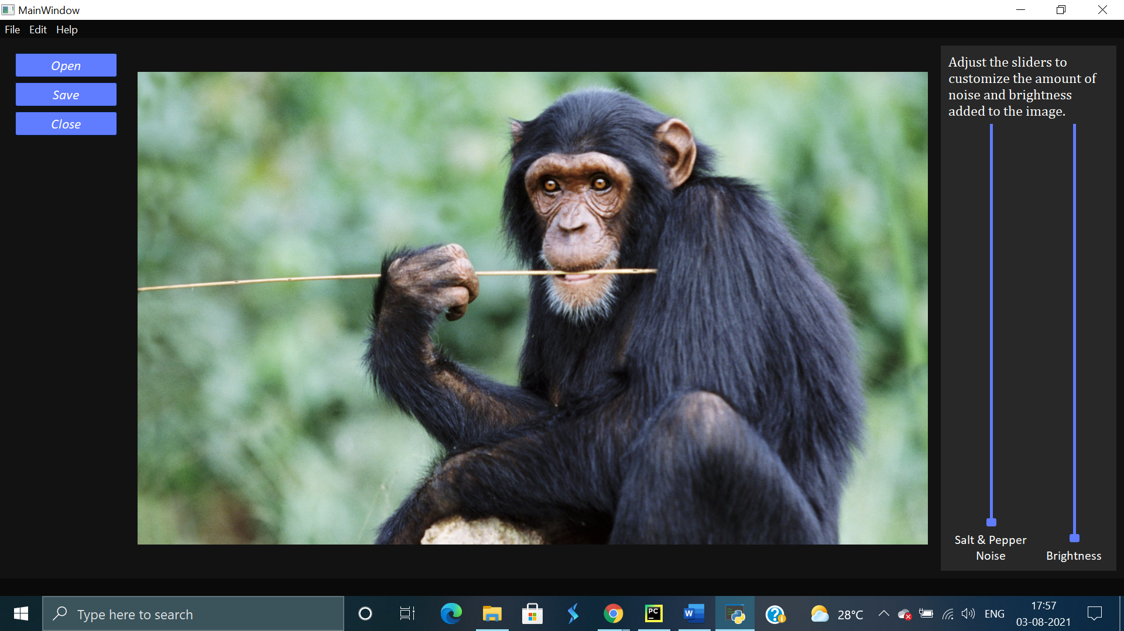

The slider at the side can be adjusted to add any amount of noise.

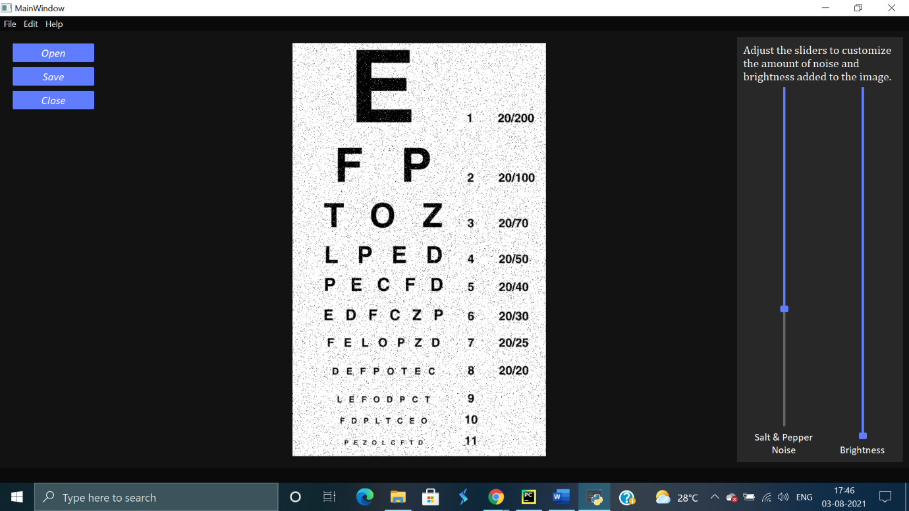

The brightness and noise values can be changed simultaneously to get any configuration required.

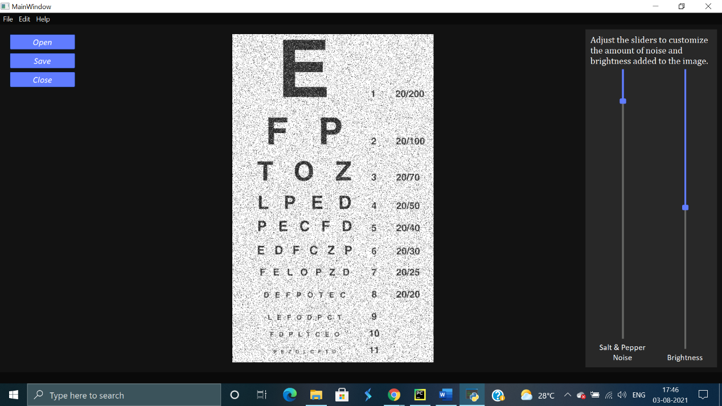

Finally, this image can be saved in any directory. The noise and brightness configurations stay intact according to the adjustments. It can be saved as:

* jpg
* png
* tiff
* bmp

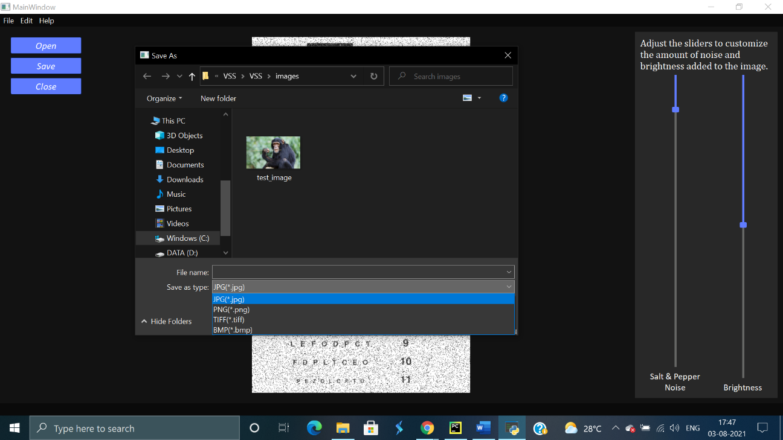

Even if the object is originally a .png image, it can be still be saved as a .jpg or .tiff image file after the modification.

To be added in the user manual:

1. Menu bar functionality
2. In the menu bar functionality, the help section
3. Pictures of error messages once completed
4. Saving the text file with final value
5. Full screen